CloudGuardian - Azure Week 3 Setup Guide
Deploying the Remediation, Approval, Governance and Privacy-Preserving LLM Stack
A complete walkthrough, written the same way as the Week 1 setup guide - file by file, then step by step. Assumes Week 1's Terraform stack is already deployed and running.
Part 1 - A Quick Tour of the Project Files 2
1.1 terraform/ - new files added for Week 3 2
1.2 logic_app/approval_workflow.json 3
1.3 automation/Test-RemediationDrift.ps1 3
1.4 functions/ - the Python remediation engine 3
1.5 privacy_llm/ - the tokenization pipeline 4
Part 2 - Step by Step: From Zero to a Running Demo 5
Before You Start 5
Step 1 - Gather Your Week 1 Resource Names 5
Step 2 - Unzip / Place the Week 3 Project 5
Step 3 - Fill in terraform.tfvars 5
Step 4 - Initialize and Deploy the Week 3 Stack 5
Step 5 - Deploy the Python Function Code 5
Step 6 - Confirm the Function App Is Live 6
Step 7 - Verify ACS Email Is Ready (no manual step needed) 6
Step 8 - Confirm the Logic App Deployed Correctly 6
Step 9 - Test the Auto-Remediate Path (Low/Medium, no approval) 6
Step 10 - Test the Approval Path (High/Critical) 6
Step 11 - Check the Audit Trail 7
Step 12 - Test the Governance Runbook 7
Step 13 - Try the Privacy-Preserving LLM Pipeline Locally 7
Step 14 - Shut Down When You're Done for the Day 7
Troubleshooting Common Errors 9
Command Cheat Sheet 9

Part 1 - A Quick Tour of the Project Files
Week 3 adds five new folders on top of Week 1's terraform/ folder: terraform/ (new files only), logic_app/, automation/, functions/, and privacy_llm/. Same rule as Week 1: Terraform reads every .tf file in a folder together as one blueprint - the order below is the order that makes sense to READ them in, not an execution order.

1.1 terraform/ - new files added for Week 3
versions.tf / providers.tf - version pins, same pattern as Week 1
Pins azurerm (~> 3.110) and random (~> 3.6). An earlier design also needed the azapi provider to deploy a hand-authored Logic App JSON workflow; that's gone now that the Logic App is a thin native-HCL forwarder (see 1.5 below), so the provider list stayed as simple as Week 1's.
variables.tf - the settings panel - now points AT Week 1 instead of creating new infrastructure
Unlike Week 1, almost every variable here is 'existing_...' - the name of a resource Week 1 already built (Resource Group, Log Analytics Workspace, Key Vault, Storage Account, SQL Server/Database). Week 3 does not create a new environment; it attaches automation to the one you already have.
locals.tf - naming + data-source lookups
Generates names for Week 3's own new resources (Function App, Event Grid Topic, Logic App, Automation Account, ACS Communication/Email Service) and looks up Week 1's existing resources via `data` blocks so the rest of the stack can reference them.
function_app.tf - the remediation engine's compute
A Python Function App on the Consumption (Y1) plan with a System-Assigned Managed Identity - no passwords, no connection strings. Also creates the small Storage Account every Function App needs for its own runtime state (separate from the Week 1 Storage Account being remediated).
rbac.tf - the least-privilege custom role
Defines a custom role, 'CloudGuardian Remediator', containing only the exact actions the 6 remediations need - not built-in Contributor - and assigns it to the Function App's and Automation Account's Managed Identities, scoped to the Resource Group only.
event_grid.tf - the routing layer
One Event Grid Custom Topic that every finding gets published to, and two subscriptions that split traffic purely on severity: Low/Medium go straight to the Function App; High/Critical go to the Logic App for approval.
logic_app.tf - the thin orchestration layer
Deploys a Logic App with a plain HTTP trigger (receives the finding from Event Grid) and ONE HTTP action (forwards it to the Function App's request-approval endpoint). No M365 mailbox, no OAuth connector, no manual authorization step - the Function App does the actual email-sending and decision-handling (see functions/function_app.py and shared/notifications.py). An earlier design tried to put the Approve/Reject branch inside the Logic App itself via the Office 365 Outlook connector, which needs a real Microsoft 365 mailbox and a manual Portal click; this design needs neither.
acs_email.tf - the email-sending infrastructure
Provisions Azure Communication Services (Communication Service + Email Service + an Azure-managed sending domain) and grants the Function App's Managed Identity permission to send through it. Fully automated by Terraform - unlike an Office 365 connector, there is no OAuth consent screen to click through.
automation.tf - the governance layer
An Azure Automation Account running a PowerShell runbook on a daily schedule, checking whether any of the 6 remediated controls has drifted back to non-compliant.
outputs.tf / terraform.tfvars.example - what you get back, and the template for your own settings
outputs.tf prints the Function App name, Event Grid endpoint, Logic App name, and the ACS sender address so you can confirm email is configured correctly. Copy terraform.tfvars.example to terraform.tfvars and fill in YOUR Week 1 resource names - this is the only file you edit directly.

1.2 logic_app/approval_workflow.json
Superseded reference file only - not deployed by the current Terraform. It documents an earlier design that used the Office 365 Outlook connector's 'Send approval email' action (which needed a Microsoft 365 mailbox and a manual OAuth click) and explains what replaced it. The file itself explains the change and points to the files that matter now: terraform/logic_app.tf, terraform/acs_email.tf, functions/function_app.py, and functions/shared/notifications.py.

1.3 automation/Test-RemediationDrift.ps1
A PowerShell runbook that connects using the Automation Account's own Managed Identity (Connect-AzAccount -Identity - no stored credential) and re-checks the live state of all 6 controls. Flags drift; never silently re-fixes it.

1.4 functions/ - the Python remediation engine
host.json / requirements.txt / local.settings.json.example - Function App runtime configuration
host.json configures the Functions runtime (extension bundle, 5-minute timeout). requirements.txt pins every Azure SDK package used, including azure-communication-email for the approval/confirmation emails. local.settings.json.example is the template for local testing - copy it to local.settings.json and fill in your own values; this file is never deployed to Azure and never committed to git.
function_app.py - the four entry points
execute_remediation (HTTP, function-key protected) - callable directly for testing/demo. auto_remediate (Event Grid trigger) - Low/Medium findings, no approval. request_approval (HTTP, function-key protected) - called by the Logic App; sends the approval email and returns immediately. approval_decision (HTTP, ANONYMOUS + its own shared-secret check) - reached when a human clicks Approve or Reject in that email; calls the same dispatcher execute_remediation uses, or records a rejection, and returns a small HTML confirmation page either way.
shared/config.py, azure_clients.py, resource_id.py, audit_logger.py, remediation_engine.py, notifications.py - everything the entry points share
config.py reads and validates every environment variable (fail-fast, no hardcoded values). azure_clients.py builds authenticated SDK clients via DefaultAzureCredential (Managed Identity in Azure, your `az login` session locally - same code, no branching). resource_id.py parses ARM resource IDs. audit_logger.py wraps every remediation call with structured, queryable start/success/failure logging. remediation_engine.py is the dispatcher - the one place that maps a control_id string to the function that fixes it. notifications.py builds and sends the approval-request and confirmation emails via Azure Communication Services (same Managed Identity, no mailbox, no OAuth), and validates the shared secret the Approve/Reject links carry - see its docstring for exactly why a GET-triggered link needs that secret check instead of just an ordinary Functions key.
remediations/*.py - the 6 safe fixes, one file each
storage_public_access.py, storage_encryption.py, diagnostic_logging.py, sql_encryption.py, keyvault_firewall.py, tagging.py. Each has a `remediate(settings, resource_id, dry_run, ...)` function, a docstring explaining exactly which CIS/MCSB control it addresses and why it's safe to automate, and dry-run support so you can preview a change before it executes for real.

1.5 privacy_llm/ - the tokenization pipeline
tokenizer.py - pseudonymize before, restore after
tokenize_finding() replaces subscription IDs, object IDs, UPNs, resource names, and principal names with deterministic tokens. verify_no_leakage() is a hard guardrail that BLOCKS the outbound LLM call if anything sensitive slipped through. detokenize() restores real values only after the response comes back.
llm_client.py - the only place allowed to call an LLM
explain_finding() forces every call through tokenize -> verify -> call -> detokenize, in that order. Two ready-to-use call implementations are included: azure_openai_call (stays inside your Azure tenant boundary end-to-end) and anthropic_call (direct Claude API).

Part 2 - Step by Step: From Zero to a Running Demo
Follow this top to bottom. Total time: 45-60 minutes the first time, most of it Azure provisioning you don't have to watch.

Before You Start
☐ Week 1's Terraform stack is deployed and terraform output still works in that folder
☐ Azure CLI, Terraform >= 1.7, and Node.js already installed (from Week 1)
☐ Python 3.12 installed: python --version
☐ Azure Functions Core Tools v4 installed: winget install Microsoft.Azure.FunctionsCoreTools (Mac: brew tap azure/functions && brew install azure-functions-core-tools@4)
☐ An inbox you can receive the approval emails in - ANY email address works (Gmail, Outlook.com, a work address). No Microsoft 365 / Exchange Online mailbox is required anywhere in this stack - see the note in logic_app.tf and acs_email.tf for why.

Step 1 - Gather Your Week 1 Resource Names
From your Week 1 terraform folder, run:
terraform output
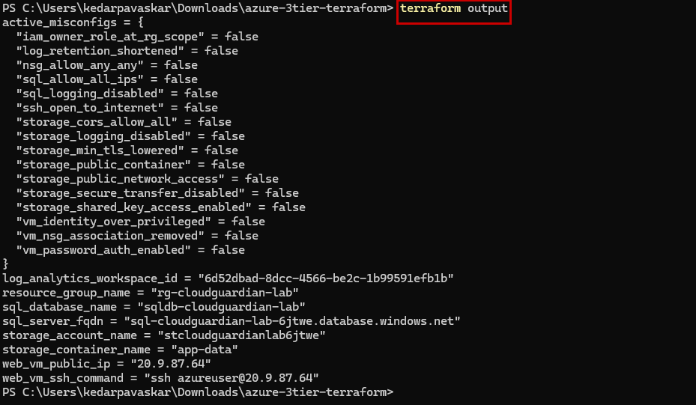
Write down (or copy) the Resource Group name, Log Analytics Workspace name, Key Vault name, Storage Account name, SQL Server name, and SQL Database name. You'll need all six in Step 3.

Step 2 - Unzip / Place the Week 3 Project
cd C:\projects\
copy the week3 folder here, next to (not inside) azure-3tier-terraform\

Step 3 - Fill in terraform.tfvars
cd week3\terraform
copy terraform.tfvars.example terraform.tfvars
notepad terraform.tfvars
Fill in the six existing_* values from Step 1, your approver_email and notification_email (your own inbox is fine), and leave everything else at its default.
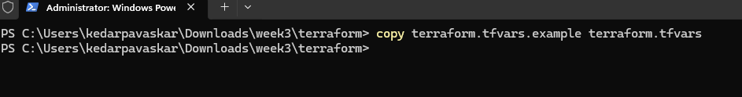

Step 4 - Initialize and Deploy the Week 3 Stack
terraform init
terraform plan
terraform apply
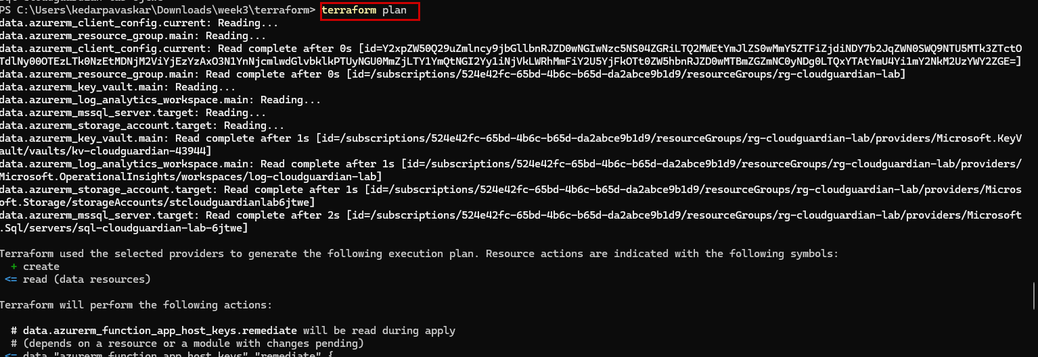
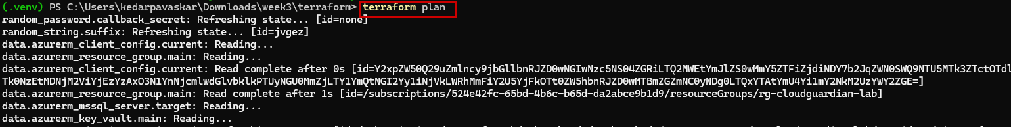
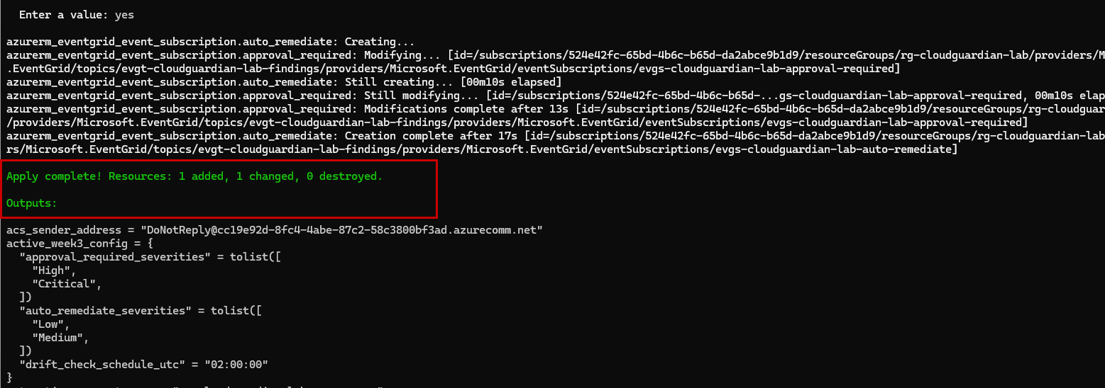
Type yes when prompted. This takes 5-10 minutes - the Function App, Logic App, Event Grid Topic, and Automation Account are the main wait. When it finishes, run terraform output and keep that output visible; you'll need several of these values in the next steps.

Step 5 - Deploy the Python Function Code
cd ..\functions
python -m venv .venv
.venv\Scripts\activate
pip install -r requirements.txt
func azure functionapp publish <function_app_name from terraform output>
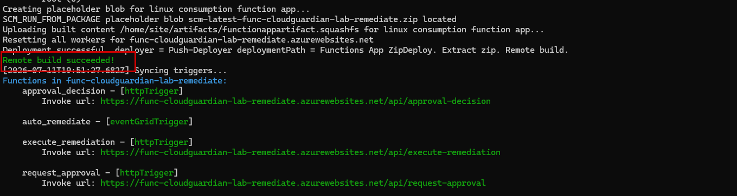
Note: The first publish can take a couple of minutes while Azure builds the Python dependencies remotely. A successful publish prints all four function names (execute_remediation, auto_remediate, request_approval, approval_decision) with their trigger URLs.

Step 6 - Confirm the Function App Is Live
curl.exe -i https://func-cloudguardian-lab-remediate.azurewebsites.net/api/execute-remediation -X POST -d "{}"
Expect an HTTP 400 with a JSON error about missing fields - NOT a connection timeout or a 404. A 400 with a JSON body means the code deployed and is running; it's rejecting your empty test request correctly.
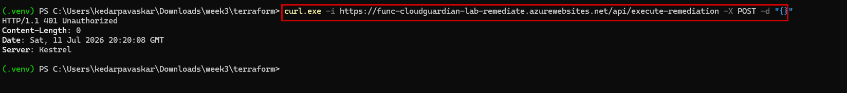

Step 7 - Verify ACS Email Is Ready (no manual step needed)
Unlike an Office 365 Outlook connector, Azure Communication Services Email needs no OAuth consent click - Terraform provisioned the send permission automatically via the Function App's Managed Identity. Just confirm it looks right:
terraform -chdir=week3\terraform output acs_sender_address
This should print something like DoNotReply@<a-guid>.azurecomm.net - not a blank value. If it IS blank, `terraform plan` will also have warned about it; see the VERIFY BEFORE APPLY comment in terraform/acs_email.tf for the one-line fix (setting acs_sender_domain_override in terraform.tfvars).

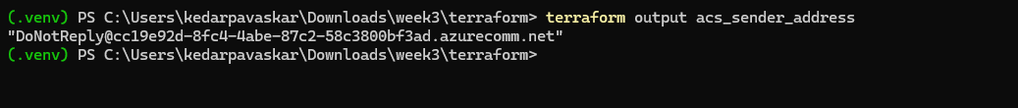

Step 8 - Confirm the Logic App Deployed Correctly
Portal -> your Logic App (logic-cloudguardian-lab-approval) -> Logic App Designer. You should see exactly two steps: the 'When_a_finding_needs_approval' trigger and the 'Request_approval' HTTP action pointing at your Function App's /api/request-approval endpoint. There is nothing to authorize here - if this Logic App shows a red warning icon, it's almost always the Function App URL/key in the action, not a connector auth issue.
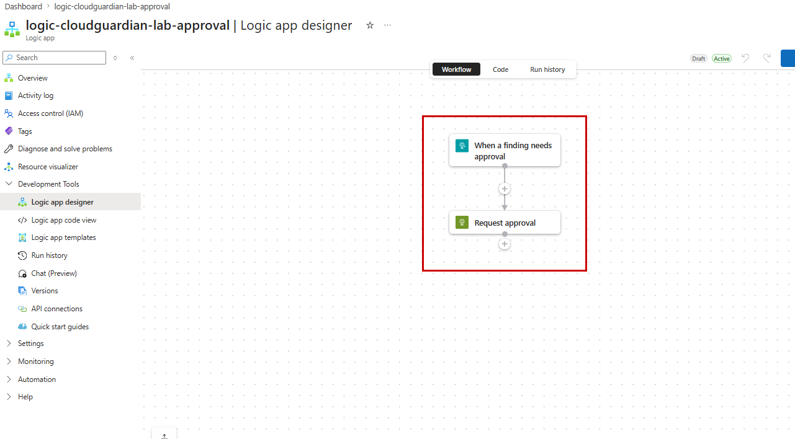

Step 9 - Test the Auto-Remediate Path (Low/Medium, no approval)
$topicEndpoint = terraform output -raw eventgrid_topic_endpoint
$topicKey = Invoke-Expression (terraform output -raw eventgrid_topic_key_command)
$sub = az account show --query id -o tsv
$rg = "rg-cloudguardian-lab"
curl.exe -X POST "$topicEndpoint/api/events" `
-H "aeg-sas-key: $topicKey" -H "Content-Type: application/json" `
-d "[{`"id`":`"t1`",`"eventType`":`"CloudGuardian.Finding.Detected`",`"subject`":`"test`",`"eventTime`":`"2026-07-11T00:00:00Z`",`"dataVersion`":`"1.0`",`"data`":{`"finding_id`":`"t1`",`"control_id`":`"tagging`",`"remediation_type`":`"tagging`",`"severity`":`"Low`",`"resource_id`":`"/subscriptions/$sub/resourceGroups/$rg`"}}]"
Within a few seconds, check the Resource Group's tags in the Portal - the 4 required tags should appear. This is the safest control to test first since tagging can't break anything.
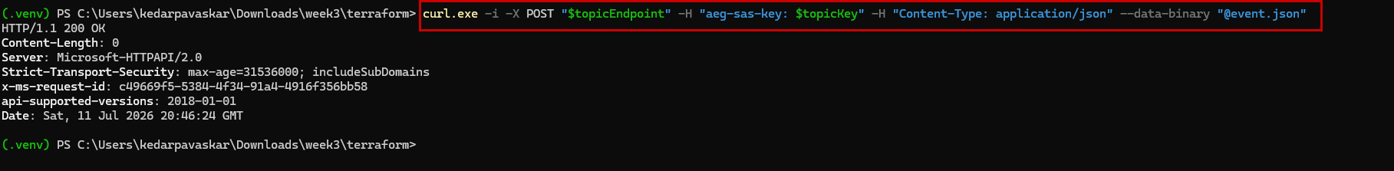

Step 10 - Test the Approval Path (High/Critical)
Repeat Step 9's curl command with severity set to "High" and control_id/remediation_type set to "sql_encryption". Check the inbox you set as approver_email for an email from your ACS sender address, then click the Approve link (a plain hyperlink, not an Outlook Actionable Message button - see the design note in functions/shared/notifications.py for why). You should land on a small confirmation page, and the SQL Database's Transparent Data Encryption blade in the Portal should flip to Enabled. A second email confirms the outcome.
Remediation 1 :
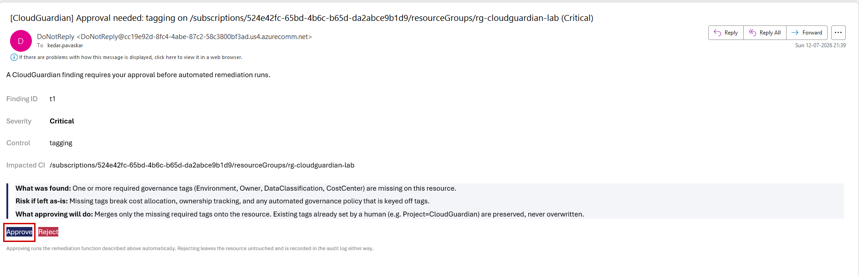

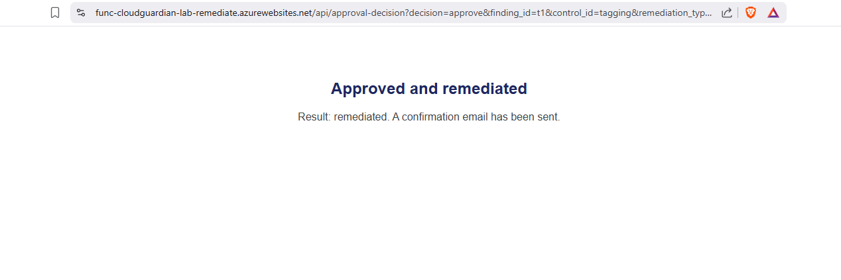

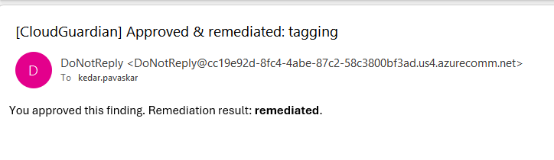

Remediation 2:
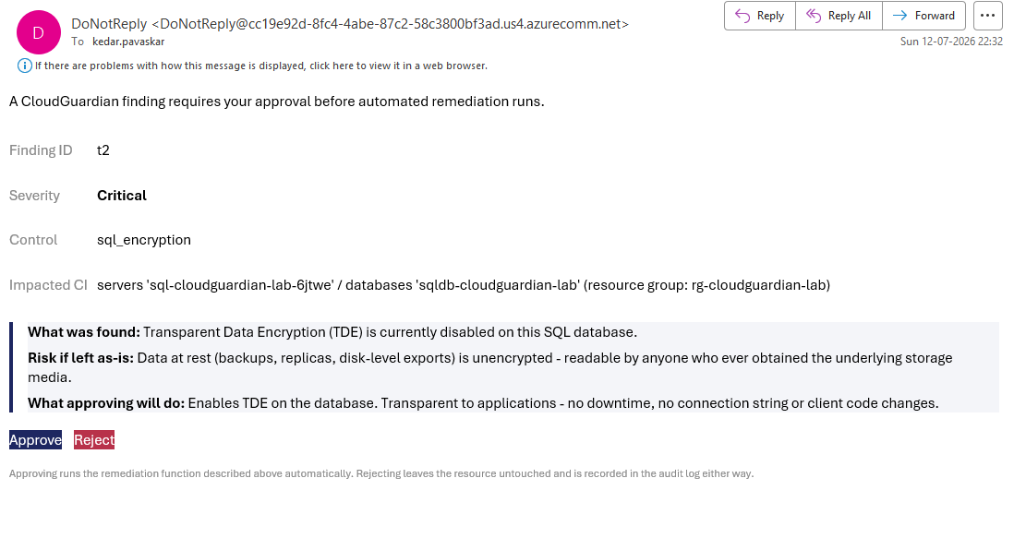
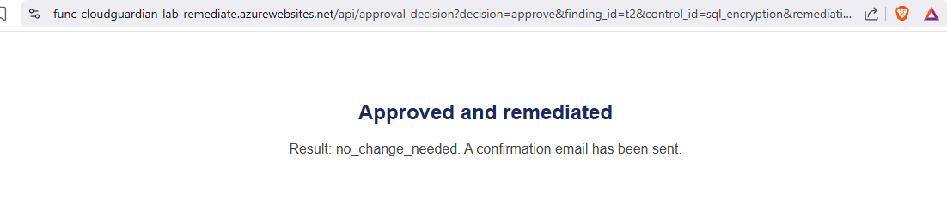
Note: Any inbox works here - Gmail, Outlook.com, a work address, anything. ACS Email only needed a special mailbox for SENDING; there was never a restriction on which address RECEIVES the approval email.

Step 11 - Check the Audit Trail
Portal -> your Log Analytics Workspace -> Logs -> paste and run:
traces
| where customDimensions.event_type == "remediation_result"
| project timestamp, tostring(customDimensions.control_id), tostring(customDimensions.outcome), tostring(customDimensions.resource_id)
| order by timestamp desc

Note: If this returns nothing, give it 2-3 minutes - Application Insights ingestion has a short delay - then re-run.

Step 12 - Test the Governance Runbook
Portal -> your Automation Account -> Runbooks -> Test-RemediationDrift -> Start (fill in the same parameters Terraform's automation.tf already wired up automatically for the SCHEDULED run - for a manual test run, paste in your Week 1 resource names). Review the job output for a 'No drift detected' or a listed drift finding.
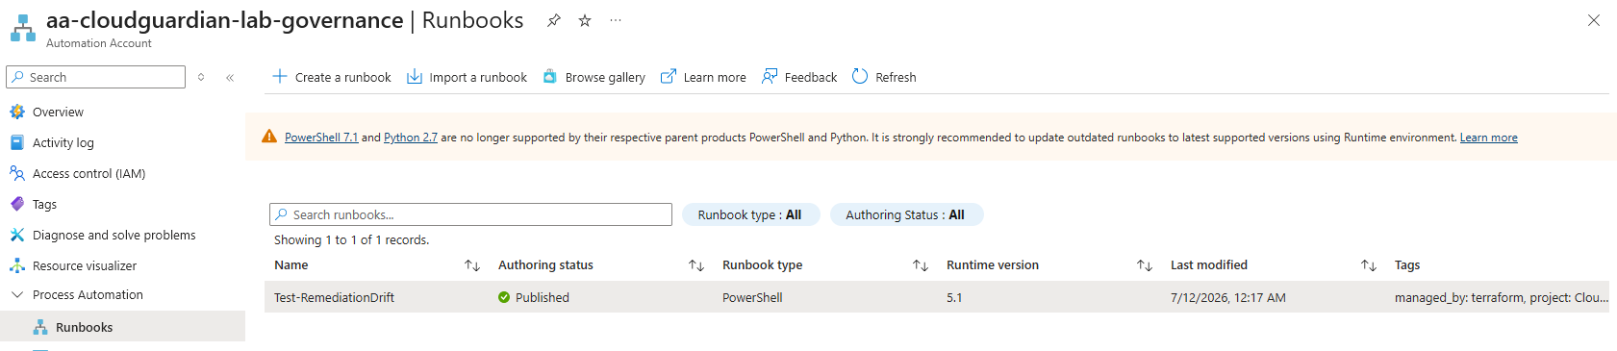
Note: Optional next step, not required for the demo: create an Azure Monitor Alert Rule on the Automation Account's JobLogs category (Warning severity) to get an email/Teams notification automatically instead of checking the job output by hand.

Step 13 - Try the Privacy-Preserving LLM Pipeline Locally
cd ..\privacy_llm
pip install -r requirements.txt
python -c "from tokenizer import tokenize_finding, verify_no_leakage, detokenize; f={'finding_id':'f1','control_id':'storage_public_access','upn':'you@example.com','resource_id':'/subscriptions/x/resourceGroups/rg/providers/Microsoft.Storage/storageAccounts/stdemo'}; s,t=tokenize_finding(f); print(s)"
You should see the subscription/resource/UPN fields replaced with tokens like RESOURCE_ID_1, UPN_1. Wire llm_client.py's azure_openai_call() or anthropic_call() to your own Week 2 LLM credentials to run the full explain_finding() round trip.

Step 14 - Shut Down When You're Done for the Day
The Function App (Consumption) and Logic App (Consumption) scale to zero and cost nothing idle. The Automation Account's daily schedule and the small Function/Logic App storage accounts have negligible cost. If you want to fully tear down Week 3 without touching Week 1:
cd week3\terraform
terraform destroy
Note: This does NOT touch your Week 1 resources - Week 3's Terraform state only contains the resources this stack created (Function App, Event Grid, Logic App, Automation Account, RBAC assignments). Re-running terraform apply rebuilds Week 3 in a few minutes against your still-running Week 1 environment.

Troubleshooting Common Errors
Error message contains... | What it means | Fix
request_approval returns 500 / no email arrives | ACS Email permission hasn't propagated yet, or acs_sender_address is blank | Wait ~5 minutes after first apply for RBAC propagation; re-check terraform output acs_sender_address (Step 7); check Application Insights traces for the exact EmailClient error
approval_decision returns Link not valid | The secret query parameter doesn't match CALLBACK_SHARED_SECRET, or you're testing with a hand-typed URL | Only click the actual link from the email - don't retype it; if you redeployed Terraform, random_password.callback_secret may have rotated, invalidating old emails' links
curl to the Function returns a connection timeout | Function App is still cold-starting, or the code didn't deploy | Wait 30 seconds and retry; re-run func azure functionapp publish and watch for errors
Event Grid subscription shows validation pending | The webhook endpoint didn't answer Event Grid's handshake in time | Re-run terraform apply - Terraform re-triggers the subscription creation
transparentDataEncryptions.get() raises a 404 | Wrong database name, or TDE current resource name changed in a newer API version | Double-check existing_sql_database_name in terraform.tfvars matches exactly; confirm with az sql db show
Automation runbook fails with Connect-AzAccount : Run Connect-AzAccount to login | The runbook wasn't given -Identity, or the Automation Account's Managed Identity role assignment hasn't propagated yet | Confirm rbac.tf's automation_remediator role assignment applied cleanly; RBAC propagation can take up to 5 minutes after first apply
PrivacyLeakError raised on every call | A real value is present in a text field that isn't a recognized structured field | Add the field to SENSITIVE_FIELDS in tokenizer.py, or pre-tokenize it before calling explain_finding()
terraform plan errors on mail_from_sender_domain (Unsupported attribute) | The azurerm provider version you have renamed/changed this computed attribute | Check the current azurerm_email_communication_service_domain docs on the Terraform Registry for the right attribute name, or set acs_sender_domain_override in terraform.tfvars using az communication email domain show instead - see the comment in acs_email.tf

Command Cheat Sheet
Command | What it does
terraform apply | deploy/update the Week 3 stack
terraform output | see Function App name, Event Grid endpoint, Logic App name
func azure functionapp publish <name> | deploy the Python remediation code
az eventgrid topic key list --name <t> -g <rg> | get the key needed to publish test events
curl -X POST "$endpoint/api/events" ... | publish a test finding to trigger the pipeline
az automation runbook start ... | manually trigger the drift-check runbook
terraform destroy | tear down Week 3 only (Week 1 untouched)

